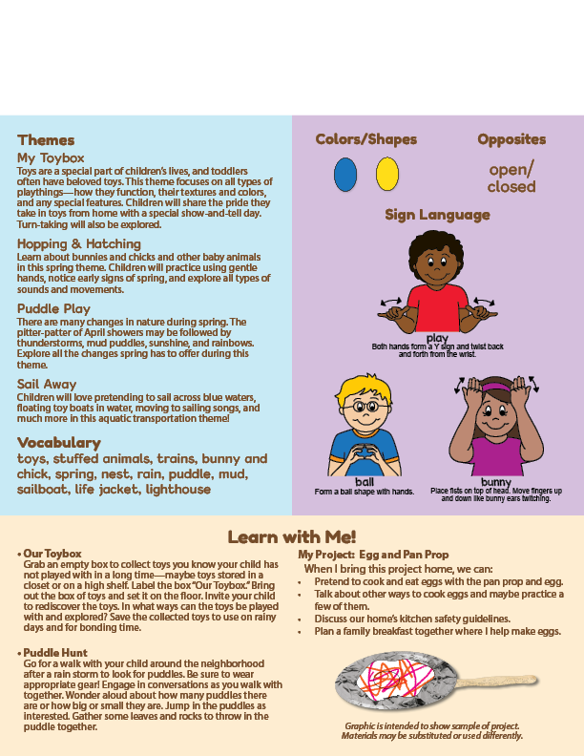

**Add Name or Logo Here**

Mar/Apr 2024

Newsletter

**Add Notes Here**