­

**Add Your Name/Logo Here**

March 2024

Newsletter

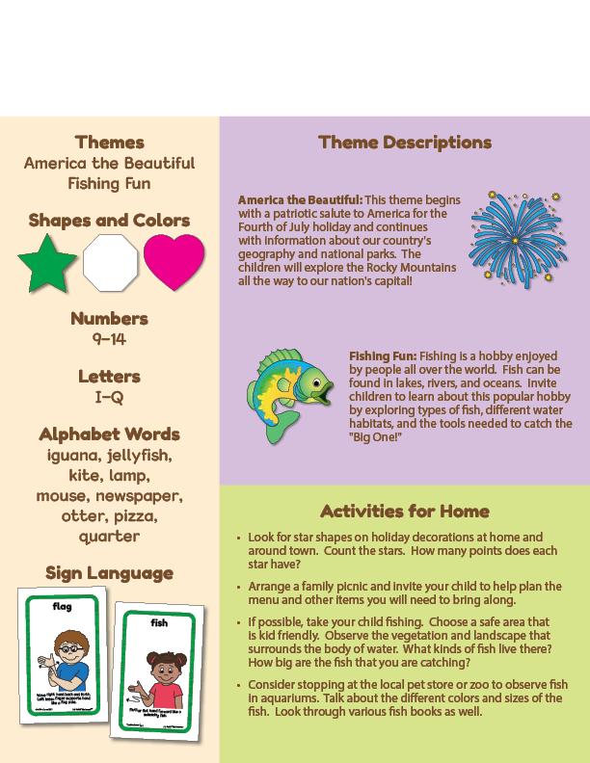Newsletter

**Add Notes**