**Add Your Name/Logo Here**

July 2023

Newsletter

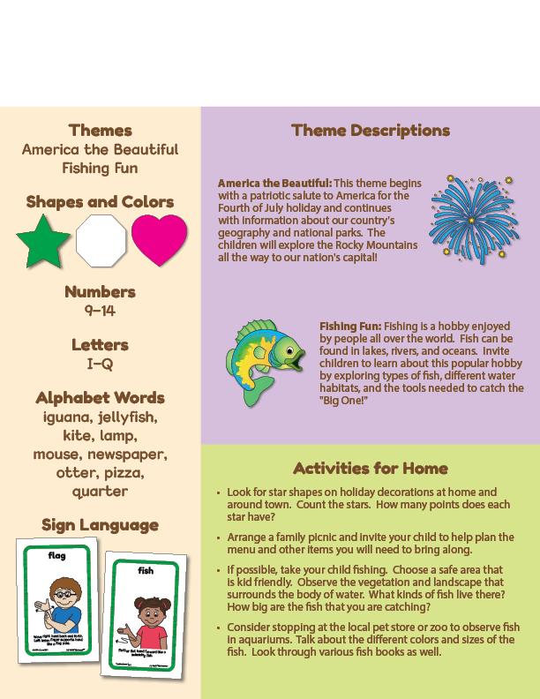Newsletter

**Add Reminders Here**